Make sure that you already made the setup of xampp and the port of mysql is 3306

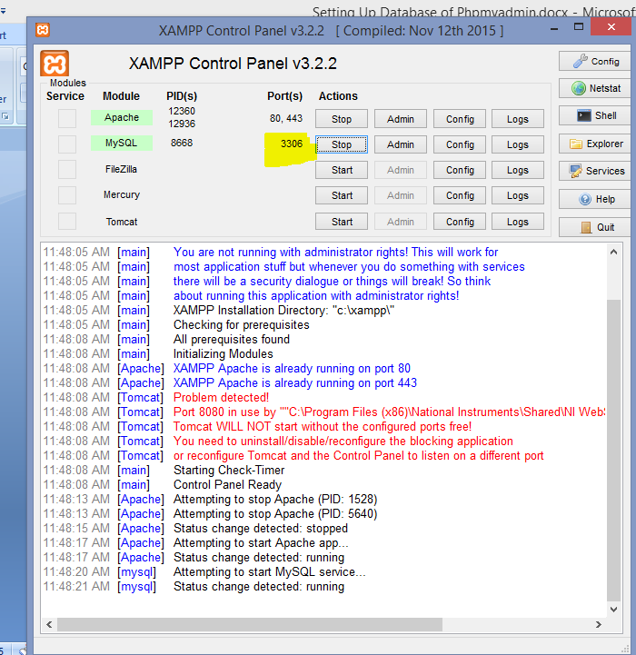

How to import database

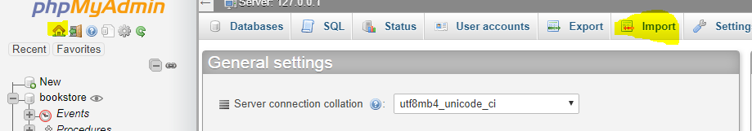

1. Click Home First
2. Click Import

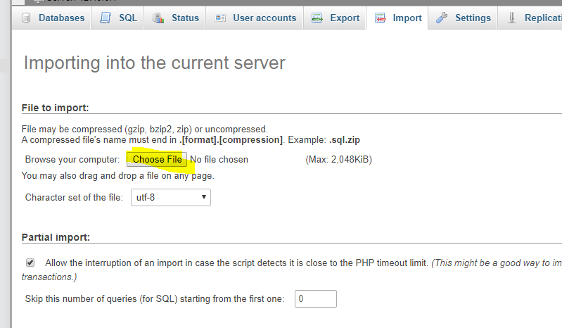

1. Click Choose file  
   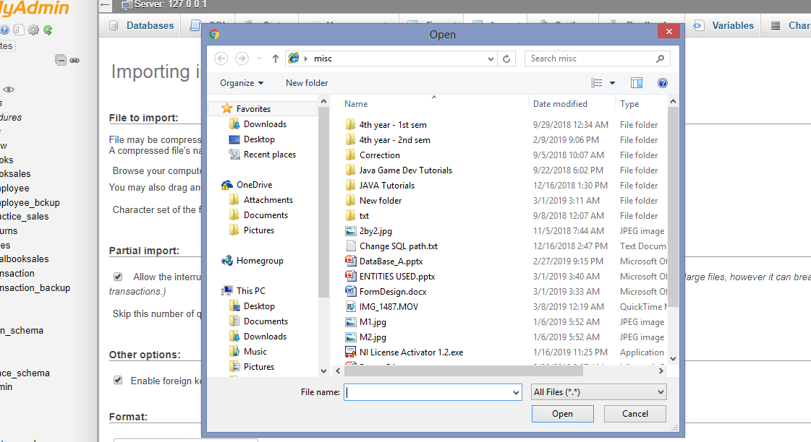
2. Choose the .sql file  
   (SQL file is shsjs.sql)

**CREATING A USER ACCOUNT**

1. **Click Home**
2. **Click User Accounts**
3. **Click Add User Account**

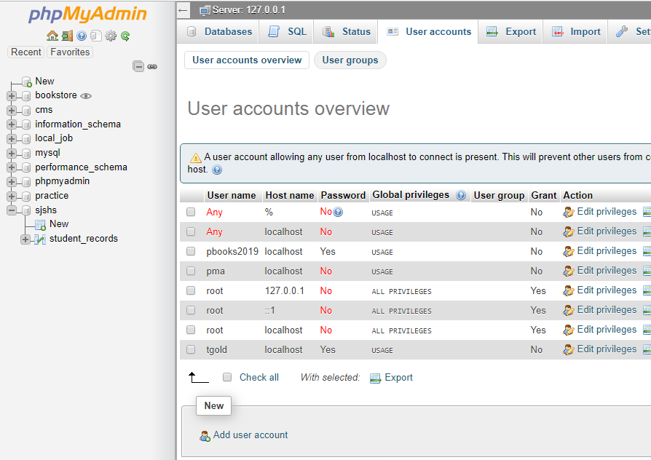

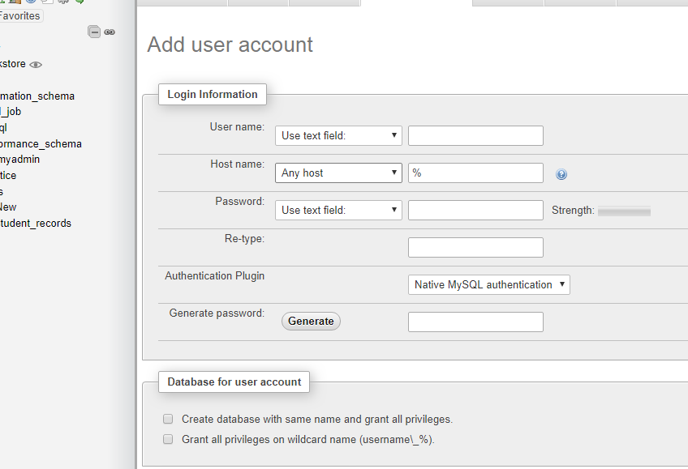

1. **Set the username, hostname, and password**
   1. **In setting hostname, click the dropdown icon and select Local. If you have already the domain don’t change it to local but enter the domain itself.** 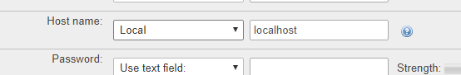
   2. **Setting the username and password is up to you**

**BUT SINCE WE SET THESE   
(See php/ConnectToDB.php)**

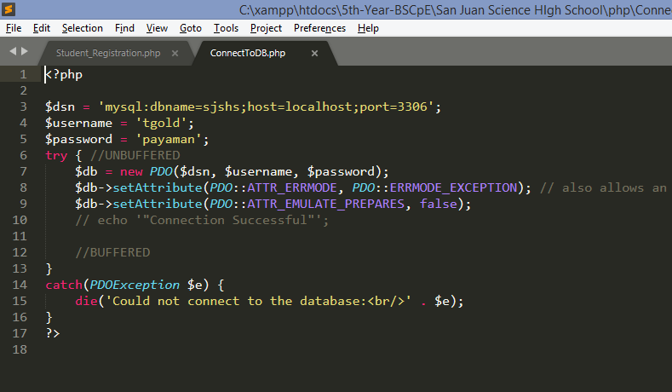

Set the username to ‘tgold’  
And set the password to ‘payaman’;

After setting these

CLICK AGAIN USER ACCOUNT

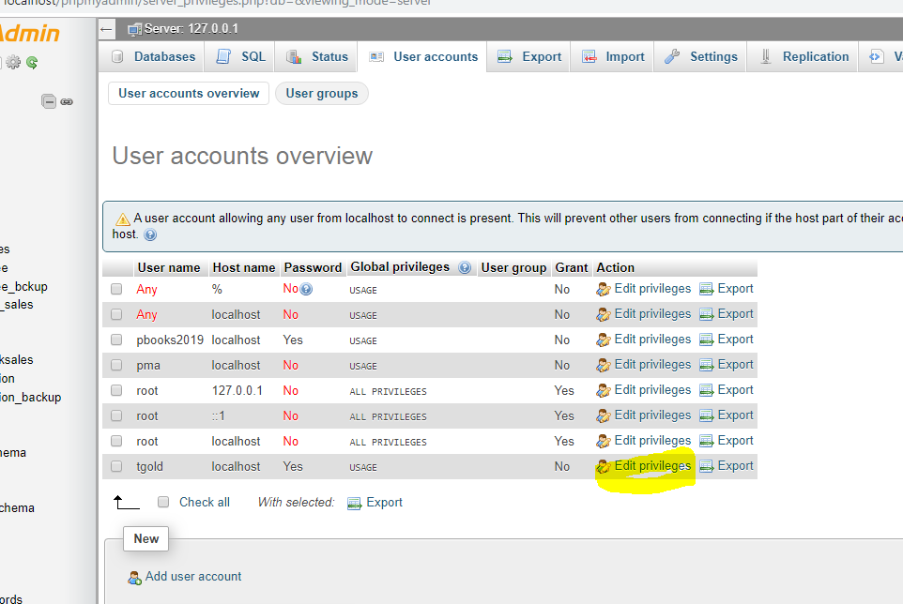

CLICK EDIT PRIVILEGES of tgold

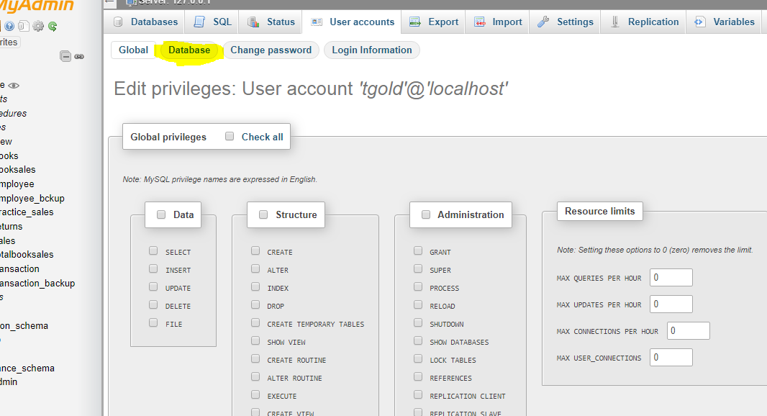

CLICK DATABASE

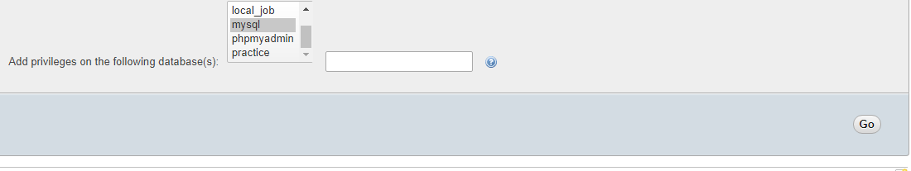

Find the database of sjshs then click GO  
  
  
END  
DATABASE IS READY